 | 26.20 Editors - Properties Editor – Strip Modifiers
Table of content
Bone Constraints 2
What is Inverse Kinematics? 2
Quick Setup 3
Adding a bone as an IK handler 3
Adding an Object as an IK handler 4
IK Constraint 5
Target 5
Bone 5
Pole Target 5
Bone 5
Pole Angle 5
Iterations 5
Chain Length 5
Use Tail 6
Stretch 6
Weight 6
Position 6
Rotation 6
Influence 6
Spine IK Constraint 6
Target 6
Influence 6
Fitting subpanel 6
Chain Length 6
Even Division 7
Chain Offset 7
Chain Scaling subpanel 7
Use Curve Radius 7
Y scale mode 7
None 7
Fit Curve 7
Bone Original 7
XZ Scale Mode: 7
None 7
Bone Original 7
Inverse Scale 8
Use Original Scale 8
Volume Preservation 8
Use Original Scale 8
Volume Variation 8
Volume Min / Volume Max 8
Smooth 8

Strip Modifiers
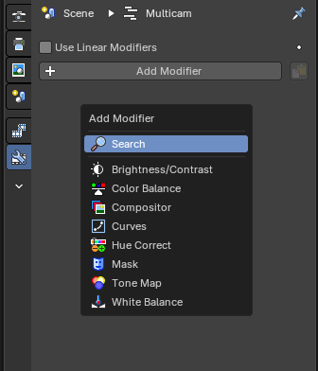
The Strip Modifiers tab allows non-destructive adjustments to video, image, and effect strips in the Video Sequence Editor (VSE). These modifiers enhance visual output without altering the original media.

Breadcrumb
This shows what scene and what strip the active selected strip tab modifiers are showing.

Pin
This pins the active selected strip modifier stack so that when you select another strip, the modifiers won’t change and remembers the pinned strip modifiers.

Copy to Selected Strips
This copies the entire modifier stack to selected strips in the Sequencer Editor timeline.
Opens a dropdown list of available modifiers to apply to the active strip.

Add Modifier

Ensures modifiers operate in linear color space. Recommended for accurate color grading and compositing workflows

Use Linear Modifiers

Modifiers

Each modifier includes its own set of parameters and can be toggled, reordered, or removed.

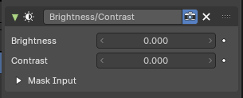
Brightness/Contrast

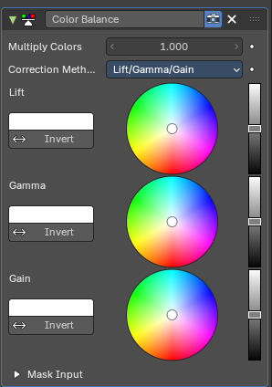
Color Balance

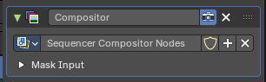
Compositor

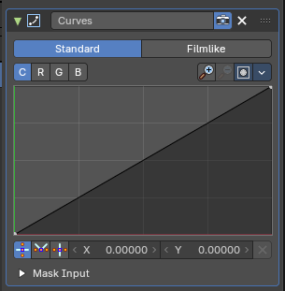
Curves

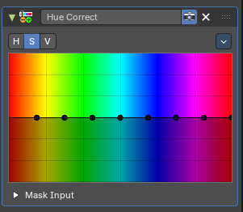

Hue Correct

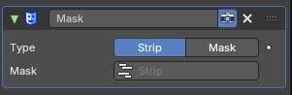
Mask

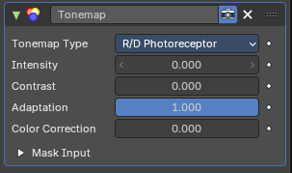
Tone Map

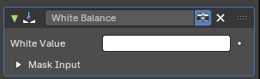
White Balance

